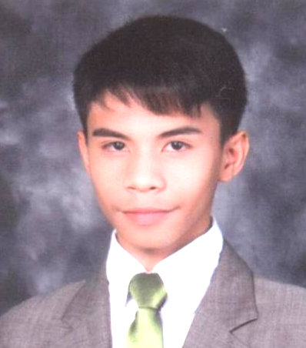
Glenn lester B Libero
#10 Corazon St. Paliparan Sto. Nino Marikina City
Mobile no.0909-2474073
Birthday: December 13,1993
Email:glennlibero@yahoo.com
Website:www.poopsielibero.weebly.com

CAREER OBJECTIVES
To acquire a position in a reputable organization that will help me to develop my skills and gain impressive performance in the field of Business Administration.
WORKING EXPERIENCE

LEMON GEN. MDSE Factory staff August,2008-May,2009

QUALIFICATIONS

Can handle a variety of challenging task
Ability to work within a multicultural environment
Flexible and Self Motivated
Excellent in analytical and interpersonal skills
Proficient in Adobe Photoshop and Microsoft Word

EDUCATIONAL BACKGROUND

TERTIARY Pamantasang Lunsod ng Marikina(PLMar) Greenheights Subdivision, Concepcion Marikina city Bachelor of Science in Business Administraton ( Present)
SECONDARY Sta. Elena High School W.Paz St. sta Elena Marikna City ` 2006-2009
ELEMENTARY Marikina Elemantary School Sta. Elena, Marikina City 2000-2006
ORGANIZATION
Center For Pop Music Philippines Member 2007-2008
ACHIEVEMENTS
Best in Arts(Singer of the year)Marikina elementary school.

CHARACTER REFERENCES
Josielyn DP. Belalo-Marketing Supervisor LEMON GENERAL MERCHANDISE Antipolo City.

