Legalization of abortion rejected

By JENNY F. MANONGDO

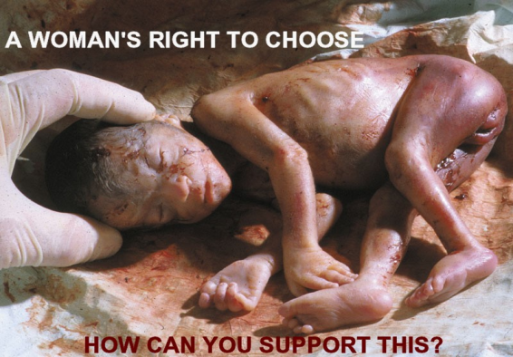
The Philippine Legislators’ Committee on Population and Development Foundation, Inc. (PLCPD) on Saturday rejected the call of an international group to legalize abortion in the country to stop women from undergoing unsafe abortion procedures, causing many of them to suffer and die.
Instead, PLCPD said the congress should push for the passage of the Reproductive Health, Responsible Parenthood, and Population Development Bill that would allow couples to have access to legal and medically safe family planning methods to reduce unplanned pregnancies that would result in the reduction of abortions in the country.
“The PLCPD and authors of RH bills stressed further that the proposed measure does not consider abortion as a family planning method. In fact, the guiding principles of the bill state that “nothing in this Act changes the law on abortion.” PLCPD, however, emphasizes that though abortion is not legal, the government should ensure that all women needing post-abortion care must be treated in a humane and non-judgmental manner,” Ramon San Pascual, PLCPD executive director, said.
PLCPD is an advocacy group composed of lawmakers concerned with making legislations and population and development.
“Legalization of abortion is not the right approach to address the increasing number of motherdying every day due to pregnancy and pregnancy-related complications.”
Last week, the New-York based human rights group Center for Reproductive Rights (CRR) released a study that pictured the ‘harmful impact’ of abortion on women who suffer because abortion is illegal in the country and there is lack of reproductive health services.
“Criminalization of abortion has not prevented abortion in the Philippines, but it has made it extremely unsafe, leading to the preventable death of thousands of women each year. In practical terms, children have needlessly lost their mothers, husbands lost their wives, and parents have lost their daughters,” the study “Forsaken Lives: The Harmful Impact of the Philippine Criminal Abortion Ban” said.
The study enumerated the unsafe abortion methods that women undergo to end their pregnancy. These are painful abdominal massages by traditional midwives, inserting a catheter into the uterus, medically unsupervised consumption of Cytotec (the local brand name for a drug containing misoprostol) to induce uterine contractions, and ingestion of herbs and other concoctions sold by street vendors.
The CRR stressed that most women resort to unsafe abortion methods to protect their health or to address unwanted pregnancy, resulting from rape, incest, or inability to control their fertility through contraception.
But the PLCPD insisted that the legal and “culturally-sensitive” way to reduce pregnancy-related deaths is for women and couples to practice family planning, provide skilled birth attendants for every delivery, and establish basic and emergency obstetric care accessible in urban and rural settings.

