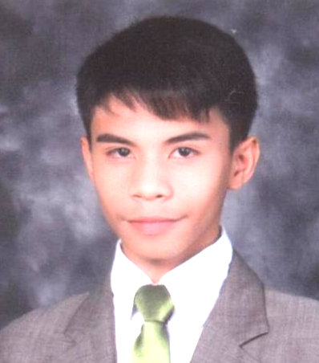
Glenn Lester B. Libero
#10 Macopa St. La Unica III Cupang Antipolo City
Mobile no.09065386437
Birthday: December 13, 1993
Email:glennlibero@yahoo.com
Website:www.poopsielibero.weebly.com

CAREER OBJECTIVES
To acquire a position in a reputable organization that will help me to develop my skills and gain impressive performance in the field of Business Administration.
WORKING EXPERIENCE
Company Position Employment Date
LEMON GEN. MDSE Factory Staff August,2008-May,2009
Sitel Philippines Inc. Customer Service Associate Jan.6-2012-July 3,2012
JOLLIBEE FOOS CORP. Customer Service Associate Jan.10-May 31,2011
Convergys Services Corp. Customer Service Associate July 23,2012 - December 17,2012

QUALIFICATIONS
Can handle a variety of challenging task
Ability to work within a Multicultural Environment
Flexible and Self Motivated
Excellent in analytical and Interpersonal skills
Proficient in Adobe Photoshop and Microsoft Word

EDUCATIONAL BACKGROUND

TERTIARY Pamantasang Lunsod ng Marikina(PLMar) Greenheights Subdivision, Concepcion Marikina city Bachelor of Science in Business Administraton ( Undergrad)
SECONDARY Sta. Elena High School W.Paz St. sta Elena Marikna City ` 2006-2009
ELEMENTARY Marikina Elemantary School Sta. Elena, Marikina City 2000-2006
ORGANIZATION
Center For Pop Music Philippines Member 2007-2008
ACHIEVEMENTS
Best in Arts(Singer of the year)Marikina Elementary School.
CHARACTER REFERENCES

Irish Cortez-Supervisor Contact number:09175426362 Convergys Corporation
Anna Patricia Ramirez Contact number:09276236135 Convergys Corporation
Manda Advincula Contact number:09177326236 Sitel Philippines Inc.

